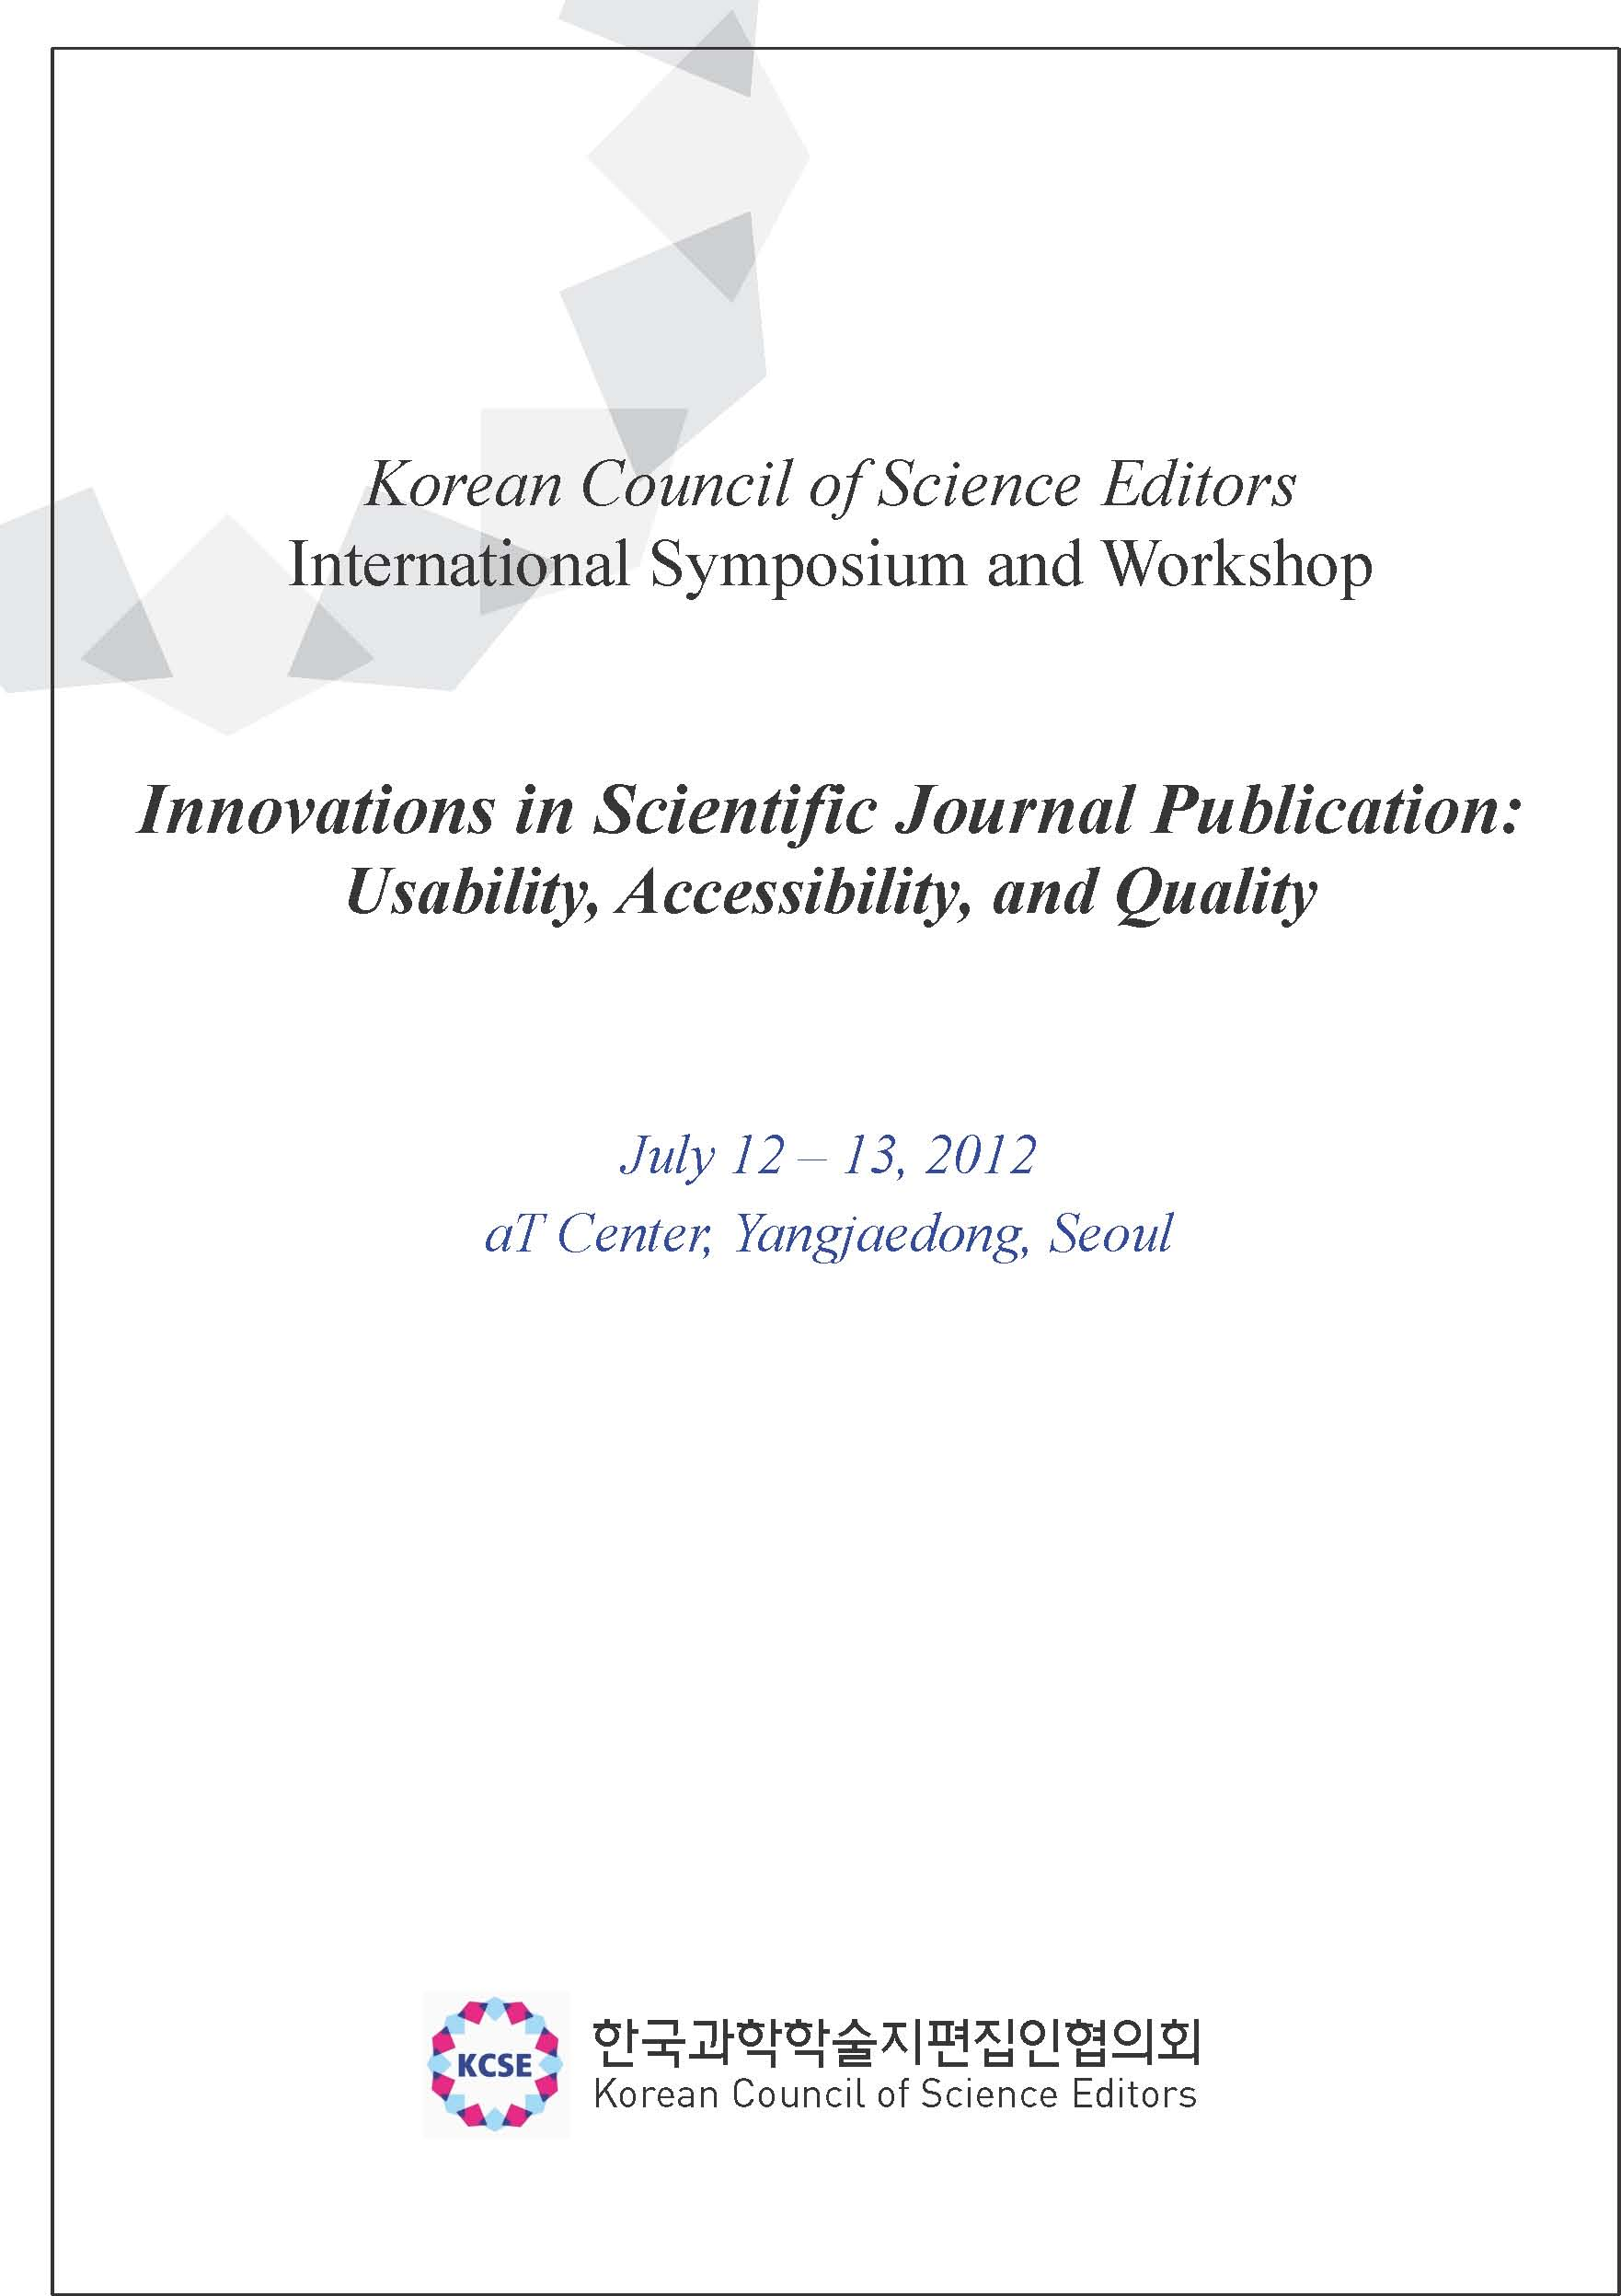
Schedule at a glance

- Symposium Program (July 12, 2012) –In English

Theme: Usability, accessibility, and quality of scientific publication

※ Registration 09:00-09:30
Welcome Addresses |  | - Chair: Hyungsun Kim  (Professor, Inha University)
09:30-09:40 | Jung-Il Jin (President of Korean Council of Science Editors)  Sang-Dai Park (President of Korean Federation of Science and Technology Societies)
Plenary Lecture |  | - Chair: Jung-Il Jin  (President, Korean Council of Science Editors)
09:40-10:40 | Excellence in research and communication through publication  Yuan Tseh Lee (Nobel Laureate, President, International Council for Science)
10:40-10:50 | Coffee Break
10:50-11:40 | Sixteen years of KAMJE: What has been accomplished?  Chang-Ock Suh (President, Korean Association of Medical Journal Editors)
11:40-11:50 | Photo Session
11:50-13:30 | Lunch
Afternoon Session Ⅰ |  | - Chair: Jong Kyu Ha  (Professor, Seoul National University)
13:30-14:00 | How can Science, Technology and Medicine (STM) journals survive in the  era of communication technology like social networking services?  Muncho Kim (Professor, Korea University)
14:30-15:00 | The current state of the STM journals of Korea and the editor's role  Sun Huh (Professor, Hallym University)
15:00-15:20 | Coffee Break
Afternoon Session Ⅱ |  | - Chair: Kihong Kim  (Professor, Ajou University)
15:20-16:00 | Physics journal publishing in Japan: Present and future  Masashi Takigawa (Professor, University of Tokyo)
16:00-16:40 | How has DOI/Crossref/CrossCheck influenced the STM journal network?  Geoffrey Bilder (Director of Strategic Initiatives, CrossRef)
16:40-17:00 | Closing Remarks

- Workshop Program (July 13, 2012) – In Korean

Theme: How to implement technical innovations in local scientific journals

※ Registration 08:30-09:00
Morning Session |  | - Chair: Sun Huh  (Professor, Hallym University)
09:00-09:50 | How to participate in CrossRef and how to produce DOI XML  Yong Sun Bahn (Professor, Yonsei University)
09:50-10:00 | Coffee Break
10:00-10:50 | How to realize the cited-by function  Taesul Suh (Manager, Korea Institute of Science and Technology Information)
10:50-11:00 | Coffee Break
- Chair: Hyungsun Kim
(Professor, Inha University)
11:00-11:50 | Vision for CrossRef upto the end of the 21st Century  Geoffrey Bilder (Director of Strategic Initiatives, CrossRef)
11:50-13:00 | Lunch
Afternoon Session
13:00-13:50 | How to use CrossCheck for the prevention of plagiarism or duplicate  publication  Eun Seong Hwang (Professor, University of Seoul)
13:50-14:00 | Coffee Break
- Chair: Eun Seong Hwang
(Professor, University of Seoul)
14:00-14:50 | How to use CrossMark for the web page of each paper  Hye-Min Cho (Chief Executive Officer, InfoLumi)
14:50-15:00 | Coffee Break
15:00-15:50 | How to participate in ORCID  Jaeseok Choi (Professor, Gyeongsang University)
15:50-16:00 | Closing Remarks

Innovations in Scientific Journal Publication: Usability, Accessibility, and Quality

1. 심포지엄 (July 12, 2012)
- 주 제: Usability, accessibility, and quality of scientific publication
- 일 시: 7월 12일 (목), 09:30~17:00
- 장 소: aT센터 5층 대회의실
- 노벨상 수상자 Yuan Tseh Lee 초청강연
- 참가비: 무료 (점심제공, 선착순 300명 마감)
- 영어로 진행

2. 워크숍 (July 13, 2013)
- 주 제: How to implement technical innovations in local scientific journals
- 일 시: 7월 13일 (금), 09:00~16:00
- 장 소: aT센터 3층 중회의실 1, 2
- 참가비: 회원단체소속 1인당 5만원
비회원단체 소속 1인당 10만원 (점심제공, 선착순 100명 마감)
- 한국어로 진행

3. 등록 및 문의처
- 한국과학학술지편집인협의회 이메일( kcse@kcse.org) 로 6월 15일(금)까지 참가신청서 등록
- 입금계좌: 시티은행 186-01081-244-01 (한국과학학술지편집인협의회)
(※ 워크숍 참석자에 한하며 송금시 성함 또는 단체명을 기입해주시기 바랍니다)
- 문 의: 과편협 사무국 (Tel. 02-3420-1390 / e-mail. kcse@kcse.org)
- 오시는 길 (가급적 대중교통을 이용해 주시기 바랍니다)

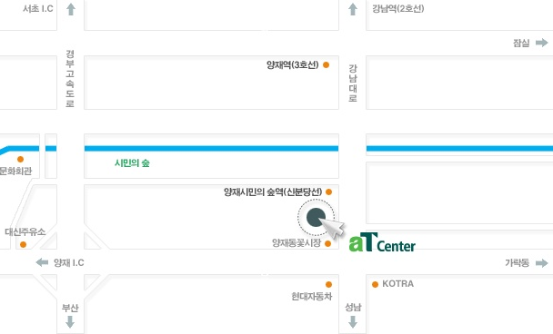
지하철
신분당선 ‘양재시민의 숲’역 하차 후,
4번 출구에서 약 50m 직진
간선버스
140, 405, 407, 408, 421, 440, 441, 462, 470, 471
‘aT센터’ 하차
자선버스
4432 ‘aT센터’ 하차
광역노선버스
9404, 9408, 9409, 9503 ‘양재 시민의 숲’ 하차

※ KCSE 국제 심포지엄과 워크숍 참가신청서
참석자소속 | 이름 | e-mail | 휴대전화 | 심포지엄  참석여부(O표기) | 워크숍  참석여부(O표기)

1. 참가 신청서는 과편협 이메일로 6월 15일(금)까지 제출하여 주시기 바랍니다.
2. 반드시 사전에 접수하신 후 참석하여야 하며, 참가신청이 많을 경우 선착순 접수로 참가자를 제한할 수 있습니다.
한국과학학술지편집인협의회 귀중

주 소: (우) 135-703 서울 강남구 테헤란로 7길 22(한국과학기술회관 신관 2층)
전 화: 02-3420-1390 E-mail : kcse@kcse.org

